# **16th Annual EDUG Meeting**

Thursday, 6 October 2022

## **Opening remarks and agenda**

## Elise Conradi welcomed members to the 16th Annual EDUG business meeting with an extra welcome to our new member, Dmitra Hioti from the National Library of Greece. She apologized for having to cancel the planned meeting in Oslo in May due to travelling problems during the pandemic. She hoped that our next meeting in 2023 will be in person.

## **Minutes of the digital meeting 2021**

*Approved*

## **Proposed revision to the EDUG Cooperation Agreement**

Elise Conradi gave a background to the proposed changes to the Cooperation Agreement. The rules about the executive committee were written without thought about how a small group of members could fit into the rules about limitation of periods. The text was revised in 2007 and now all members, not only institutional members can serve as officers.

The three options for revision were presented:

1. All members are entitled and encouraged to serve on the Executive Committee. Members of the Executive Committee can be elected from the General Meeting for two years and may be re-elected.
2. All members are entitled and encouraged to serve on the Executive Committee. Members of the Executive Committee can be elected from the General Meeting for two years and may be re-elected once. After an interval of two years (one period) a former officer may be elected as though they had not served before.
3. The Executive Committee is comprised of members appointed by EDUG Institutional Members on a rotating basis for two years at a time. The institution having its turn appoints Chair and Secretary. After two years, the next institution takes over. The previous Chair or Secretary becomes Vice Chair and assists the new institution to ensure a smooth transition.

Option 1) was unanimously chosen and we could then start the election.

## **Election of office bearers 2023-2024**

### **Chair**

### Harriet Aagaard was elected as chair

### **Vice-Chair**

Tina Mengel was elected as vice-chair

### **Secretary**

### Jo Maxwell was elected as secretary

### Harriet commented that more people should volunteer in future elections. It is quite fun to be part of the board.

## **National reports (brief summaries)**

*See reports in the Appendix.*

## **Report from OCLC/EPC**

*See report in the Appendix.*

## **Presentation EDUG 15 years**

Elise Conradi reminded us of our past 15 years. We have had meetings in all institutional countries and interesting symposia. EDUG started by forming working groups for 340, 370 and 930 and delivering suggestions for changes in Dewey. There was also an IT working group that looked at how to best make use of Dewey in search systems; preferably with Dewey as linked data. Presentations at the symposia have been about Dewey in our countries; translations; number building and facets in DDC; mapping Dewey to other vocabularies and classification schemes; use in end-user systems; automatic classification and machine learning; and about Dewey as Linked data.

At the meeting in Naples 2015, we held a workshop about mappings sponsored by the University of Oslo that resulted in [guidelines posted on the EDUG web](https://edug.pansoft.de/tiki-index.php?page=EDUG+workshops).

The last years we have had many discussions about using Dewey in a machine readable form - Dewey as linked data. In 2015 OCLC closed down an earlier linked data version of Dewey and we sent [national statements](https://edug.pansoft.de/tiki-index.php?page=DDC+in+Europe) with use cases about our needs of Dewey as linked data.

We have also presented new features in both WebDewey and in the translation software.

In 2013, Lars Svensson tried to look ten years into the future[1]. Elise ended by commenting on his visions.

In 2013 Lars Svensson was quite optimistic about the future. He expected Dewey to keep on being available as linked data, but it is not. He thought that there would be an explicit versioning of DDC classes. This is somewhat related to the discussion we have had about time stamps instead of edition in bibliographic records.

The second prediction was that DDC would be more interoperable. We should have mappings between Dewey and several other KOS systems. There should be an infrastructure in place to distribute these mapping. Elise reminded us of the mapping tools we now have, like CCMapper, but they are not really used to make retrieval in library catalogues better.

Dewey integration in interfaces is mainstream. Major web sites use Dewey to organize their content. End users should have a seamless integration into library catalogues and library portals.

Lars ended by asking if this was the future or still a dream. Elise commented that even though we still have another year until the 10 years Lars talked about will take place, it does not seem likely that all this will happen in one year.

## **Discussion/Information**

* 1. **Where is EDUG in 5 years from now?**

Harriet Aagaard started the discussion by describing two very different futures.

* + - 1. Dewey is freely available as linked data and used as a standard all over the world.  
         Lars Svensson’s ideas from 2013 have come true.
      2. Dewey is not available and used less and less. Why should libraries classify with full DDC numbers if Dewey is only used as a shelving system in physical libraries? We have already seen that Dewey is becoming less used in searches in web catalogues and discovery systems. An example is that in the 2022 version of WorldCat online it is no longer possible to search with Dewey and not possible to use in advanced search.

Elise thought that we have other options. If OCLC does not publish Dewey as linked data, we can do it together as we all have the rights to our own language versions.

Heidrun Alex commented on web catalogues. She thought that DNB’s new catalogue was worse than the earlier.

Terrence supported Heidrun’s remark about web catalogues. They are becoming more like Google and do not request user education. But, Dewey has a great advantage as it is language free and can be used in many countries. Librarians should educate users in universities to be able benefit from Dewey. In the British Library catalogue it is possible to search with Dewey, but it is not obvious how to do that. We should make better use of Dewey.

Harriet plan to use a lot of energy to help the next version of [Libris webbsök](https://libris.kb.se/) to keep the possibility to search by classification. Subject specialists need to think about use of subject metadata in web catalogues and not think that others will think do this.

Peter informed us that very little software development has been done during the past 1-2 years. Interest in development can be seen as an interest in Dewey.

Terrence thought that the trend of using FAST instead of LCSH could strengthen the use of Dewey since you get a place for a subject in a discipline, not just a term.

* 1. **Meetings moving forward: Physical, hybrid or digital? Fixed rotation of hosts?**  
     Elise asked us what kind of meetings we would like to have in the future. It may become more difficult to travel in the future due to concerns about the environment or budget restrictions. Many institutions will prefer digital meetings in the future instead of “unnecessary travel”. Terrance was worried about economic restrictions.

Elise thought that it has not been difficult to get hosts to volunteer so far, but should we have a system with a fixed rotation? Terrance thought that it could be difficult as an institution may get into problems a few years into the future. Elise commented that EDUG in the past years have used a loose fixed order of hosts, but it has been flexible.

The meeting decided to have a physical meeting next year and continue the discussion.

* 1. **Translators’ forum: bimonthly meeting and wiki**  
     Tina Mengel reported about the WebDewey Translation Partners.

Bi-monthly meetings started early 2021

* Standing agenda:
  + Review backlog of open questions
  + Discuss software enhancements across WebDewey
  + Consider improved workflows and ways to collaborate across teams
  + Discuss current work plans and projects
  + Discuss future work plans, projects, and strategies
  + Current topics, e. g. Dewey as linked data

Who is in the group?

From OCLC: Alex Kyrios (Dewey editor), Sandi Jones (Product Manager) & occasional guests (depending on topics discussed).

Representatives from translation teams:

Harriet Aagaard (Sweden), Micheline Brûlé (France/Canada), Piero Cavaleri (Italy), Elise Conradi (Norway, EDUG), Rania Osman, Manal Balbaa (Egypt/Arabic language), Tina Mengel (Germany), Peter Werling (Pansoft)

Open in terms of how long the group will continue in this constellation, and if other translation teams might want to join this group.

Main topics tackled so far:

* DDC Translation Guidelines & Dewey Translation Wiki.   
  The Dewey Translation Wiki was shown by Tina Mengel as an add-on to the national report from Germany.
  + Introducing your DDC language version
* Reuse of deleted but valid built numbers
  + Result of the discussion recorded in a new paragraph 1.7 in the DDC translation guidelines
* International use of user-contributed numbers
  + Workflow for international sharing of built numbers
* International sharing of built numbers (1)
  + More language versions make use of the user-contribution feature in WebDewey
  + The same number may have been added to more than one language version
  + duplication of efforts
  + Different numbers may have been added for the same topic
  + due to different interpretation of DDC instructions / different focus of expressing a topic / different focus in cataloging
* International sharing of built numbers (2)
  + Based on quality criteria
  + Based on the standardized vocabulary of the Relative Index (that is used for built numbers)
  + Enriching the DDC with useful international Dewey numbers
  + Help detect international topic trends, or nests of missing built numbers in specific areas
  + Help detect areas in DDC that need reviewing
* International sharing of built numbers (3)
  + Status: Workflow ready
  + Implementation requires joint (financial) effort.

## **Issues and plans for 2023**

* 1. EDUG 2023

Our next meeting will be in Oslo in May 2023, hosted by the National Library of Norway.

### **Other EDUG business**

Ingebjörg Rype mentioned in her national report that the need for time stamps had been discussed in connection to the large update of Graphic design. Harriet commented that Swedish cataloguers also had discussed time stamps. Harriet has made a request for development of automatically set time stamps when classifying in Libris, the national union catalogue. She has been in contact with LC, but asked the present EDUG members if any library had implemented time stamps.

Alex commented that time stamps are available in MARC21 and linked to [MARC21 specifications for Authorities](https://www.loc.gov/marc/authority/ad082.html) and for [Bibliographic specifications](https://www.loc.gov/marc/bibliographic/bd082.html) in the chat.

Rania Osman was interested to hear more about the development and Harriet will keep EDUG posted.

Dmitra was intrerested in finding thesauri with Dewey numbers, preferably in English. Elise answered that the mapped vocabularies should be of interest.

## **Appendix: OCLC/EPC report and National reports**

### **OCLC Report by Alex Kyrios, Editor**

This year saw the resumption of full EPC meetings, though Meeting 143 was still conducted virtually. We met in two-hour blocks over the course of three days, which allowed for a workload comparable to traditional face-to-face meetings, though still on the lighter side. By now, changes from EPC 143 are all live in WebDewey, so I’d just like to highlight two of them, each of which illustrate important trends in DDC development.

First, systemic bias in the classification continues to be a major priority for addressing, in line with OCLC’s diversity, equity, and inclusion (DEI) initiatives. Many other knowledge organization systems are grappling with similar issues. In late 2021, I began outlining five large areas that need attention: terminology for groups of people, names of Indigenous groups, LGBTQ+ issues, Western bias, and Christian bias. Terminology issues are relatively easy to address, while structural issues will be the work of many years.

Returning to the context of EPC 143, in early 2022 we had our first Editor-in-Residence, a flexible program for temporary DDC editors that focus on specific topic areas. This first holder, Kelly West, identified a batch of potentially problematic terms and created an exhibit to replace them, which EPC approved. This also provides a model for addressing other terms, both those already in the classification and to reflect changing usage, when today’s preferred terms become tomorrow’s nonpreferred.

Second, the previously vacant 744 has been filled out with a new development for graphic design, communication design, and related design topics. This was created in close collaboration with a design professional and DDC editors, and is probably the most substantial change to the classification since the 2011 publication of the print DDC 23 (angiosperms being the only other contender for this title).

I anticipate an electronic Meeting 143A in January, and hope for a return to in-person annual meetings beginning this summer.

OCLC has been regularly meeting with translators to discuss issues of common interest, including collaborative workflows and technical enhancements. Tina Mengel discussed this work in further detail at this business meeting.

Earlier this year, OCLC released [WorldCat Entities](https://entities.oclc.org/), a linked data system including persons and works from the WorldCat database. As mentioned in the [press release](https://www.oclc.org/en/worldcat/oclc-and-linked-data/worldcat-entities.html/), several EDUG member institutions have been part of the advisory work leading up to this stage. I am aiming to have DDC be a crucial part of the next phase of OCLC linked data work, since it is uniquely positioned to be both a subject vocabulary and a bridge to other knowledge organization systems.

### **National report from Biblioteca Alexandria by Rania Osman**

During the Year 2022, the uploading of the Arabic translation of *Volume 4 Relative Index* has been continued and it is still a work in progress. In order to move forward with the uploading phase, non-BA volunteer uploaders joined the team; and they received ‘tailored training sessions’ on using the *PANSOFT International DDC Translation Software* delivered by the DDC Translation Project Coordinator and the BA-PANSOFT liaison officer, Ms. Manal Balbaa. The sessions specifically targeted a group of students specialized in language and translation, and more groups of volunteers are expected to join the *Volume 4 Relative Index* uploading phase.

Moreover, it is planned to pursue the upgrading to WebDewey after the uploading phase of the Relative Index Arabic translation is finalized. In this respect, a preliminary technical implementation of the upcoming Arabic right-to-left WebDewey has been set forward by PANSOFT GmbH. The BA-PANSOFT continuous fruitful cooperation is further enhanced by an official work-mission invitation to the DDC Translation Project Coordinator to attend meetings at PANSOFT GmbH, in October 2022, about the preliminary technical implementation of the Arabic right-to-left WebDewey, as well as discussing a number of technical issues encountered on the Translation Software.

It is worth mentioning that the completion of the Arabic translation of DDC Volumes 1, 2, and 3, Edition 23 with updates up to March 2019, was highlighted and showcased in the October 2022 BA exhibition on the occasion of celebrating 20 years since the revival of the iconic ancient landmark of the Library of Alexandria, which was a hub for prominent scientists, philosophers and scholars about 2000 years ago.

### **National report from Austria**

### **National report from the British library by Terrance Mann**

Firstly, an update from Heather Rosie, our Electronic Theses Online Service (EThOS) Repository Metadata Manager. As of 30th September 2022, there were 610,535 records on EThOS, of which 569,688 had been assigned an Abridged DDC number (93%). Dewey is used for third party data supply where a subject-based dataset is required, and is also available as an Advanced Search option on the BL catalogue ([https://explore.bl.uk](https://gbr01.safelinks.protection.outlook.com/?url=https%3A%2F%2Fexplore.bl.uk%2F&data=05%7C01%7C%7Ca6822c9400454d7d732508dac326f2e9%7C21a44cb7f9c34f009afabd1e8e88bcd9%7C0%7C0%7C638036869291498441%7CUnknown%7CTWFpbGZsb3d8eyJWIjoiMC4wLjAwMDAiLCJQIjoiV2luMzIiLCJBTiI6Ik1haWwiLCJXVCI6Mn0%3D%7C3000%7C%7C%7C&sdata=ysHhZGxV6IUJMDxyJ1yVNPsv6cuD2E5bbiHbMAiydEE%3D&reserved=0)). The full dataset in CSV format, with subject disciplines derived from the Dewey class numbers, may be downloaded from the BL Research Repository: [https://doi.org/10.23636/kvwc-ty06](https://gbr01.safelinks.protection.outlook.com/?url=https%3A%2F%2Fdoi.org%2F10.23636%2Fkvwc-ty06&data=05%7C01%7C%7Ca6822c9400454d7d732508dac326f2e9%7C21a44cb7f9c34f009afabd1e8e88bcd9%7C0%7C0%7C638036869291498441%7CUnknown%7CTWFpbGZsb3d8eyJWIjoiMC4wLjAwMDAiLCJQIjoiV2luMzIiLCJBTiI6Ik1haWwiLCJXVCI6Mn0%3D%7C3000%7C%7C%7C&sdata=jiOIFQ%2FLAwYSo3gFq3iV4%2BHX19TS9KZRdnRGqCCAIds%3D&reserved=0). As the dataset is very large, and principally aimed at researchers working in specific subject areas, the theses have been grouped into 19 disciplines based on DDC class number. These disciplines have been mapped from the HESA (Higher Education Statistics Agency) Subject Codes ([https://www.hesa.ac.uk/support/documentation/jacs/hesa-codes](https://gbr01.safelinks.protection.outlook.com/?url=https%3A%2F%2Fwww.hesa.ac.uk%2Fsupport%2Fdocumentation%2Fjacs%2Fhesa-codes&data=05%7C01%7C%7Ca6822c9400454d7d732508dac326f2e9%7C21a44cb7f9c34f009afabd1e8e88bcd9%7C0%7C0%7C638036869291498441%7CUnknown%7CTWFpbGZsb3d8eyJWIjoiMC4wLjAwMDAiLCJQIjoiV2luMzIiLCJBTiI6Ik1haWwiLCJXVCI6Mn0%3D%7C3000%7C%7C%7C&sdata=bDemwP5eGAQDuZQVk48F0f8LowSihOg%2Bw5b22BJH6IQ%3D&reserved=0)). The total number of theses in each disciplines currently stands as follows:

### **EThOS Totals by Discipline**

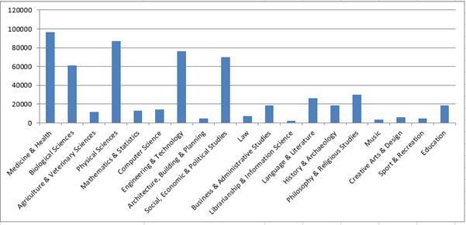

Incidentally, we currently have a PhD student from University College London who is using this dataset to look at gender trends over time within and across disciplines. She informs us that her research fundamentally relies on the subject classification available in EThOS: “Having the discipline information derived from DDCs has been really useful in my PhD research on gender inequalities in higher education. As it is an expert-assigned ground truth, I can use to accurately group PhDs in EThOS together into disciplines to examine gendered patterns within and between disciplines, as well as over time and across universities.”

Secondly, the BL hopes to recommence work on a project to generate DDC numbers from its former *Science Reference & Information Services Classification Scheme* *(SRIS)* in the near future. As previously reported, this hybrid project is based on a mapping of the old SRIS schedules to DDC. Machine processing is used to add DDC to bibliographic records containing the equivalent SRIS class in areas where it is both safe to do so and justified by user transactions – classifiers signing the same in areas not meeting these criteria. To date the project has assigned DDC numbers in *Astronomy*, *Geology*, *Pharmacology*, *Medicine*, *Mathematics* and the *Animal Kingdom*, with *Chemistry* now on the horizon. The current state of play is as follows:

### **BL Metadata Quality Mapping, SRIS Classification to DDC and LCSH**

|  |  |  |  |  |
| --- | --- | --- | --- | --- |
| **SUBJECTS** | **No. records for global update** | **Records with Multi Codes (Manual Edit)** | **Records with Single Unmatched Codes (Manual Edit)** | **TOTAL** |
| Geology | 5,100 | 428 | 489 | 6,017 |
| Animal Kingdom | 6,617 | 1,917 | 1,266 | 9,800 |
| Mathematics | 4,549 | 768 | 907 | 6,224 |
| Pharmacology | 2,062 | 324 | 667 | 3,053 |
| Medicine | 9,243 | 340 | 915 | 10,498 |
| Astronomy | 1,466 | 241 | 147 | 1,854 |
| Chemistry |  |  |  |  |
| **TOTAL** | **29,037** | **4,018** | **4,391** | **37,446** |

***Note:*** *Numbers in red represent work not yet completed on Aleph.*

Finally, various internal BL DDC workshops have been delivered online again this year – including specific courses on *Law*, *Life Sciences* and *Literature* – virtual participation having continued to prove very popular with attendees.

### **National report from France**

My name is Jean Maury, I have been working at the French National Library. Currently, I am assigned to the Metadata department as the general Dewey.

My mission is to ensure the operational coordination of all the activities which contribute to a consistent use of this classification, to manage the Dewey authority file of the BnF, to lead the network of local coordinators and to coordinate the use of systematic indexing in cataloging services.

I develop work instructions and control the consistency of indexing;

I contribute to the development of the institution's indexation policy and to the reflection on the use of indexes and classifications in the context of the semantic web;

I contribute to the production and development of the subject policy of the institution.

As a reminder, at the BnF we have and provide users with a Dewey authority file. This file is two thousand years old.

Dewey authority file that is complete with DDC numbers, headings in a clear wording, and cross-referenced forms wich roughly correspond to the index terms. The users may search the catalog according any of these. All the notes appearing in the WebDewey records for those numbers are also part of the file.

Like any authority file, its management is daily, with new creations of notices, updates, corrections. These are carried out by Dewey coordinators.

The role of the cataloger is :

* to make the link to the Dewey authorities if they exist =>

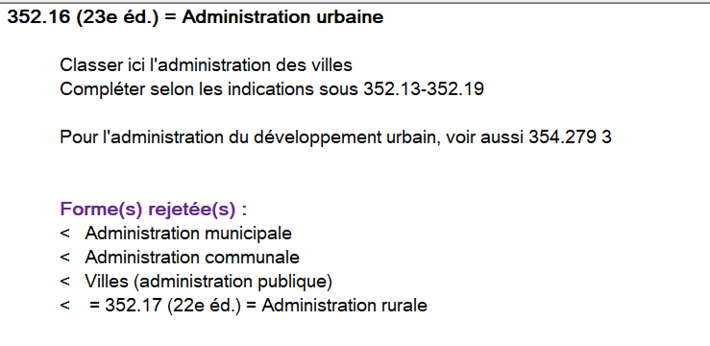

* or to complete authority Dewey with a heading if necessary, this concerns old notices from loading =>

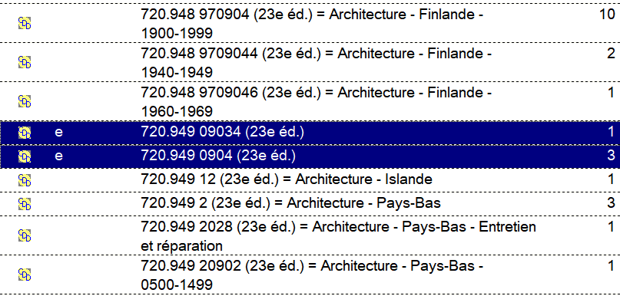

#### **Translation of the DDC23 – The WIKI tool**

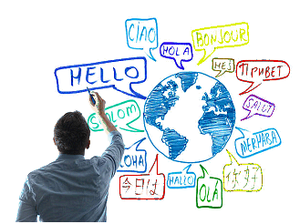

Work on the Wiki tool that is entirely dedicated to the translation project of the 23rd edition of the Dewey Decimal Classification (CDD 23) and its updates.

Les Éditions ASTED inc. are responsible for updating and translating DDC. They are in Montréal, Québec, Canada. A partnership made up of Bibliothèque et Archives nationales du Québec (BAnQ), the Bibliothèque nationale de France (BnF), and Library and Archives Canada (LAC), are responsible for the intellectual content of the French translation.

Here are some examples to illustrate this :

among the last updates in the WebDewey, some have had a significant impact on the Dewey authority file.

* Since last July, Kosovo has obtained its own geographical entity in table 2 T2--49719 Kosovo. Before, it was grouped in Serbia T2--4971 Serbie. Following this development, all the documents concerned by the subject need to be re-indexed with the correct number in Dewey.

In a forthcoming version 18 of the general catalog of the BnF, all monographic, serial and editorial serial records will indicate the heading of the Dewey. Indeed, it would have been very annoying for a subject concerning Kosovo to see Serbia appear in caption.

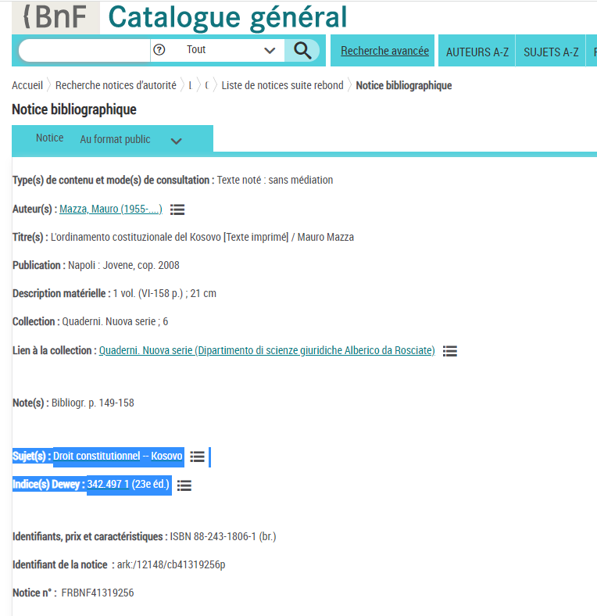

* Another development validated by OCLC concerned my request to create two separate numbers on the social effects of pandemics (303.485 7) and wars (303.485 8) which previously were grouped together with disasters (303.485).

On the other hand, when the requests are accepted, it is my responsibility to correct and re-index in Dewey the bibliographic records in the catalog that deal with these subjects. This work is quite substantial, it takes me time, but you have to know what you want....

Disasters in general – stay in 303.485

Pandemics – 303.485 became 303.485 7

Wars – 303.485 became 303.485 8

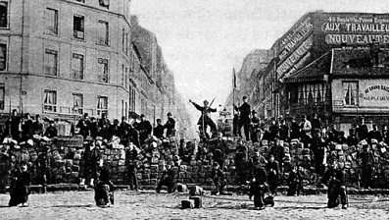

* A final request to Alex Kyrios (OCLC) has been made regarding an event in French history regarding the Paris Commune, 1871 = 944.0812. Currently this historical fact is referenced in the note "Including" not allowing it, according to the Dewey rule, to add notations from the auxiliary tables (tables of subdivisions). However, we have many publications on this subject which deserve to be specified by subdivisions, and therefore not to be swallowed up among general subjects concerning the period 1870-1899. This corresponds to approximately 500 documents. Two possibilities would be offered to users: - either to create a specific index of the style 944.08121 - or to mention this event in another type of note "Class here..." which, still according to the Dewey rules, will allow this time to subdivide.  
    
  This Request has been taken into account by Alex Kyrios (OCLC), and he suggested the solution authorizing 944.08121 which will cover the period 1870-1871, and the event corresponding to the Paris Commune will be mentioned in a "Class here..." note. Thus the number could also be used for other subjects of the period, such as the consequences of the Franco-Prussian war in France.

#### **Some important projects undertaken with the Dewey authority file:**

* A major correction project has been carried out concerning the number 347.016 for notaries. A confusion was created in the minds of the indexers because in France the function of notary is different from that of notary public, which in most common law countries is a public officer who intervenes in foreign affairs and international to complete certain formalities.

In the countries of Romano-Germanic law, namely almost all the countries of continental Europe, Russia, Asia, countries of South America and countries of the Near East, the notary often has a link of designation or subordination with his state; performing, by delegation, tasks devolved to it by its State, its field of competence is varied and, sometimes, it benefits from a numerus clausus for its installation and monopolies for certain activities; thus in France it has a monopoly for donations, marriage contracts and authentication of real estate sales.

We have thus corrected and attached the many documents dealing with notaries versus French law in 346.0023 for Civil-law notaries - Notaries (Legally trained notaries)

* Let us cite two other examples of correction have been carried out on the Dewey authorities or entirely updated, for example on Czech literature and those on the themes addressed in arts and decorative art, etc…

#### **Dewey decimal classification training:**



In October 2021, a 2-day training in Dewey indexing was given at the School of Librarians and Documentalists in Paris.

During February and March 2022, one Dewey training session of 3 and a half days took place at the BnF. It was a question, as every year, of training new catalogers including a common core part of the Dewey, another on the writing and constitution of Dewey authority records, and finally on the use of the WebDewey tool. The training was held in digital form, except for the part devoted to WebDewey.

A training specific to the WebDewey was felt by the cataloguers of the literature and art department. This was done in June 2

#### **Elementary Status Dewey authorities:**

The general coordinator Dewey is brought in the exercise of checking the Dewey indexing in bibliographic production to complete the elementary authority records contained in the catalog, coming from loads before the creation of the Dewey authority file, which dates from 2000.

Examples of basic authority records with 761.2 Wood engraving that can be used by cataloguers, provided they are enriched with a heading. When they have been completed, these notices are considered to be complete. But Dewey coordinators may also be called upon to undertake work on the recovery of elementary notices.

#### **General catalog of the BnF (public catalog)**

An upcoming meeting of the Forum catalog group will consider two requests that coordinator Dewey made for the next version 18 of the general catalog, which should be released next winter:

Display: Dewey search: modification of the presentation of textual content in the General Catalog (pages A-Z), with the addition of Dewey as a subject search

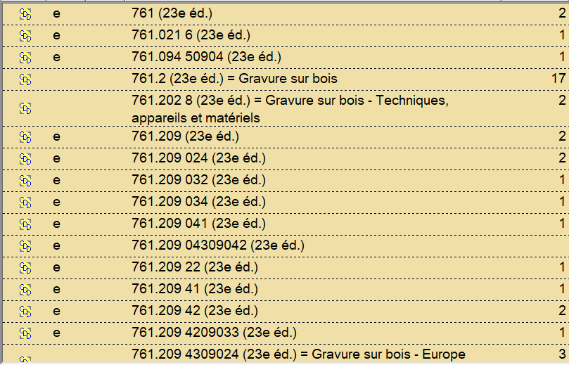

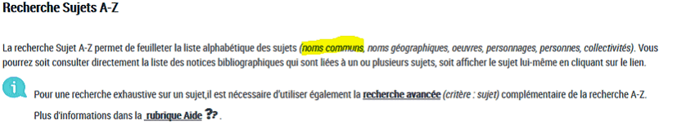

* Dewey search: generalization of the plain text display for monographies, serials and editorial serials

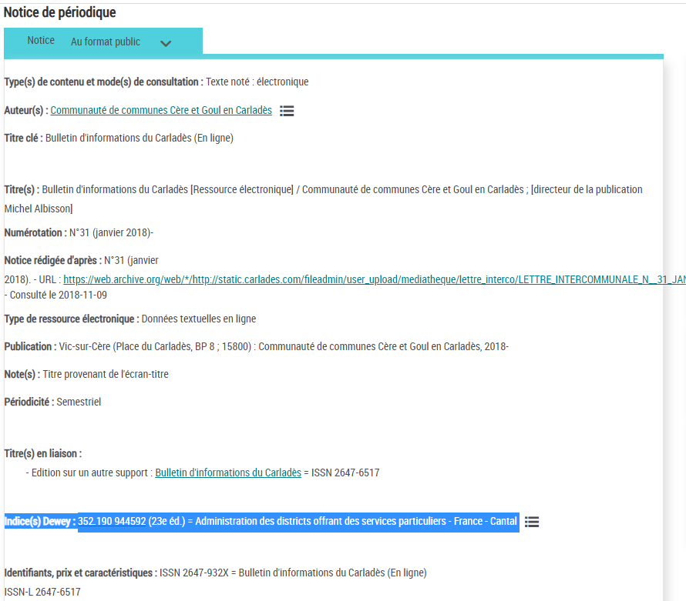

* Improved the index results list, that's to say a display that would take the form of a real index

**A-DCAT-02 :**

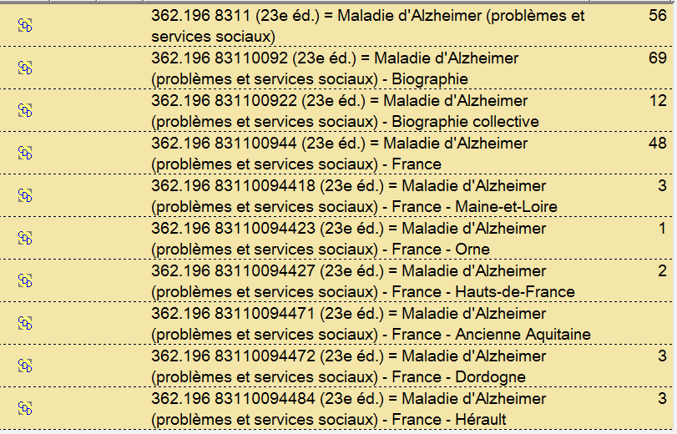

**General Catalog (public catalog)**

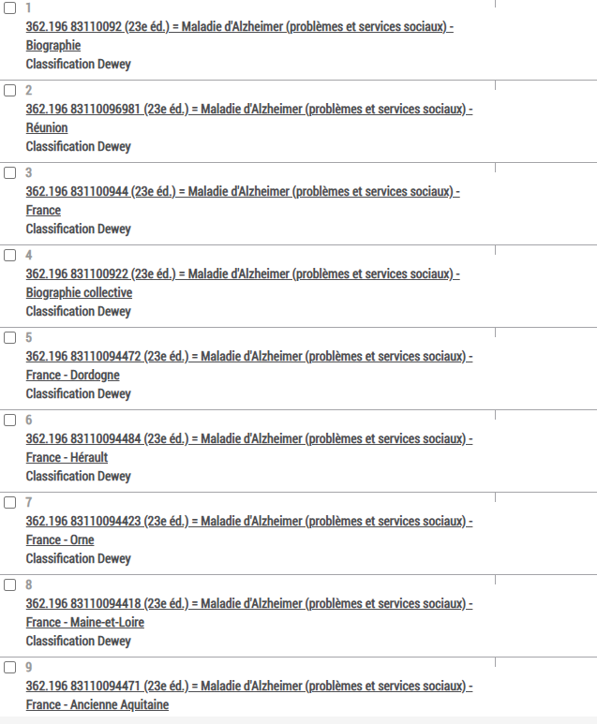

### **Deutsche Nationalbibliothek/German National Library (Heidrun Alex and Tina Mengel)**

#### **Intellectual and machine classification with DDC**

Despite the ongoing Corona pandemic, the DNB's work in 2021 ran quite normally. Home office and online meetings have become common forms of work, but especially the intellectual indexing of print publications for which there is no parallel online edition has to be done in the office.

In 2021, DNB intellectually assigned DDC Subject Categories to more than 86.000 publications and full Dewey numbers to about 40.000 publications from the publishers' booktrade.

In addition, DDC Subject Categories are still assigned automatically. Since 2012, over 1.9 million online publications and 2.7 million articles have received Subject Categories. A recent evaluation has shown that 77 % of the machine-assigned Subject Categories for online publications are correct, although there are major differences between the Subject Categories.

For DDC Short Numbers, the focus in 2021 was to replace the currently used software by the tool Annif (<https://annif.org/>). Since 2018, more than 0.5 million online publications and 1.9 million articles have received automatically assigned Short Numbers. An evaluation of the Short Numbers assigned for online publications between 2021 and June 2022 that have intellectual comparison data in the form of full Dewey numbers (which are, however, only slightly more than 13.000) shows that 50% of the Short Numbers matched exactly. However, it must be taken into account that approx. 23% of the publications already have an incorrect machine-assigned Subject Category, with the consequence that the Short Number cannot be correct at all.

Within the next two to three years we hope to achieve better results, as Annif can be better adapted to DNB’s needs. But a fundamental problem however, is that too little training data is available for a learning procedure, especially for many of the Short Numbers.

#### **Translation of DDC**

The translation of DDC updates has been continued as usual, still following the approach of reducing the backlog of older updates and at the same time updating newest updates, so that topics of high relevance get into the system without major delay.

Since a few months the DNB has been hosting a wiki space for content related to international Dewey translation. The so-called [Dewey Translation Wiki](https://wiki.dnb.de/display/DTW) is intended to be an information platform which is more focused on the information needs that Dewey translators might have. Thus, it has the potential to serve as a bridge between the more formal and general information services of OCLC’s website and the EDUG website, which has its own scope of information related to the EDUG, its members and annual meetings. Moreover, the wiki invites to provide collected and more detailed information about all Dewey language versions from one place.

The wiki space consists of two parts, one is for Dewey translators only (registration with DNB required), where they can find the translation guidelines with a lot of information and recommendations regarding Dewey translation issues. All pages in yellow shape can be freely accessed on the web. There is not so much free content to date, but the six translation teams that meet every two months at the WebDewey Translation Partners Meeting (see Top 8C) have made a start by creating an area where the language versions are introducing themselves. Web users who are interested in the DDC from an international perspective will find information there about the DDC in other countries with respect to history, editions and local or language-specific particularities, and they easily get linked to further information provided by the language versions. The content of the whole wiki space is available in English, ideas for further content are always welcome (contact: Tina Mengel).

[Dewey Translation Wiki](https://wiki.dnb.de/display/DTW)

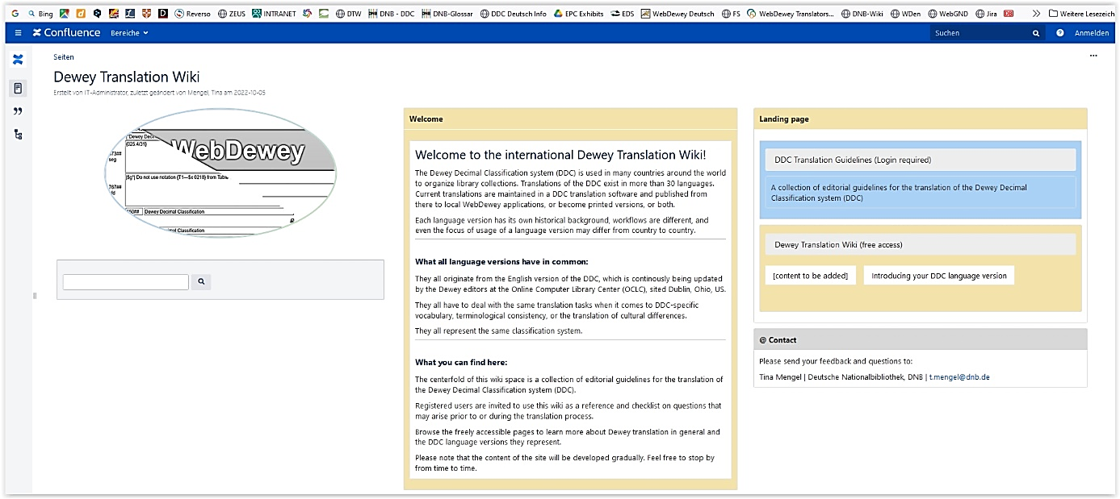

#### **The tool coli-ana**

As part of the project colibri/coli-conc of Verbundzentrale des GBV (VZG), [the tool coli-ana](http://coli-conc.gbv.de/coli-ana/), which analyses and decomposes synthesized DDC numbers, has been available since 2021:.

We are very happy that the work of many years of our EDUG colleague Ulrike Reiner – she had reported on it at the symposia 2007 and 2016 – is now available in a tool that can be used by everyone, even if the decomposition doesn't always work error-free, as tests of the DNB have shown.

### **National report from Iceland by Rósfríður Sigvaldadóttir**

In Iceland, the participants in the Consortium of Icelandic Libraries (almost 300 libraries and institutions) continue using the Dewey system. The smaller libraries use the Icelandic edition from 2002 (translation of the 13th abriged edition). It can be said that we are set in our ways of using Dewey.

The National and University Library (NULI) uses the Dewey system to organize its main collections (leitir.is) as well as for its various databases, such as:

* The National Bibliography - bokaskra.landsbokasafn.is
* The Digital Depository – rafhladan.is
* Icelandic Music and Sound Archive – hljodsafn.is

The tendency now is to use broader classification numbers due to increased use of subject headings and for the fact that Dewey numbers are not visible to the end user in the Consortium interface but are of course important for shelf browsing.

### **National report from Norway by Ingebjørg Rype**

The Norwegian WebDewey now has about 35 000 user contributed, national numbers, with about 5-10 new numbers added daily. These numbers are checked by Dewey editors at the National Library. Invalid numbers are rejected and notification is sent to the contributor. Relative Index terms are checked to make sure they follow rules and patterns in WebDewey.

Most of the time we manage to keep up-to-date on the updates of translations, but this is dependent on our overall workload. We have translated the revisions of graphic design and communication design. This is a rather huge revision, and important to inform the Dewey users of.

This revision actualizes the question of changes within the same edition (DDC 23). We have not yet started using the time stamp option in Marc 21. We think it raises some questions to be discussed. Does the time stamp have implications we have not seen? What about reuse of other language versions numbers? Even if the numbers have time stamp, do we have to go the actual language edition to see if the number is updated? The National Library will initiate a national discussion and share information about these discussions and decisions with EPC/EDUG

The last two years we have been developing WebDewey traing material on internet. This is done in cooperation between the National Library, The Library and Informations Science education, and Elise Conradi.

### **National report from Italy by Piero Cavalini**

Regarding the Italian WebDewey I can tell you that very little has changed in the last year.

We have continued to translate all the proposed updates and add the numbers proposed by our users. Regarding the software we are fully satisfied.

We are very interested in the progress of the project to share proposals for new numbers by editorial boards of editions other than the English one.

### **National report from Sweden by Harriet Aagaard**

The Swedish translation is still a mixed translation. 69,2 % is translated into Swedish. About 30 % remains to be translated. By use of the statistics feature in the translation software, updates to the translated numbers have been identified and updated.

More DDC digital training courses have been [published in Metadatabyrån](https://metadatabyran.kb.se/klassifikation/ddk/utbildningsmaterial) (a web site with instructions for Swedish cataloguers) and on YouTube. I have finally managed to make 800 with T3A-T3C available. As it is a quite difficult area to classify in DDC it took a lot of effort and support from my colleague Olof Osterman.

The National Library and most university libraries started using DDC in 2011. We will celebrate this by hosting a conference about DDC in Sweden on 10 November. It is called [DDC 10 years in Sweden](https://metadatabyran.kb.se/klassifikation/ddk/ddk-10-ar-i-sverige) even though it is a 11 years anniversary.

In preparing for presentations at the conference, I have looked at discovery systems at Swedish university libraries. Many discovery systems do not allow for advanced searches for DDC and sometimes DDC is not even indexed at all! The National Libraries discovery system is now updated and advanced search is possible.

### **National report from Switzerland by Vera Uhlman**

The number of documents to be classified had already decreased since a couple of years in view of the renovation of the library’s building. Of course, the quantity has also diminished subsequently to Covid measures.   
  
On the upside, we had the opportunity to work on the integration of our old UDC catalogue. The University of Applied Sciences of Fribourg has developed a prototype to this end and we are currently employed on cleaning up and weeding the old UDC numbers as well as the old subject headings which should be ended by the beginning of autumn. What we hope to achieve concerning the DDC is to integrate the mapping of the UDC numbers to the DDC subject categories – a full mapping demanding too many resources both in time and in money. By now, all of about 14500 notations have thus been mapped. This is a first round of course: we will have to check and recheck a number of problematic mappings.

1. [EDUG Annual Meeting 2013](https://edug.pansoft.de/tiki-download_file.php?fileId=31)